**Final Year B. Tech. (CSE) – I : 2021-22**

**4CS462 : PE2 - Data Mining Lab**

**Assignment No. 8**

**Group id: DM21G12**

**Group members:**

**Abhishek More(2018BTECS00037)**

**Sushil Wagh(2018BTECS00031)**

**Title :** Apriori algorithm

**Objective/Aim :**

1. Implement the Apriori algorithm for generating Association Rules

2. Experiment with different values of support, confidence, and maximum rule length.

3. Tabulate the results containing frequent item sets, total number of rules generated

for different support and confidence.

4. Find the interesting rules from above obtained rules using following

metrics/measures

a. Lift

b. Chi-Square Test ᵡ

c. All_confidence measure

d. Max_confidence measure

e. Kulczynski measure

f. Cosine measure

**Introduction:**

Apriori is an algorithm for frequent item set mining and association rule learning over relational databases. It proceeds by identifying the frequent individual items in the database and extending them to larger and larger item sets as long as those item sets appear sufficiently often in the database. The frequent item sets determined by Apriori can be used to determine association rules which highlight general trends in the database: this has applications in domains such as market basket analysis.

**Theory/Algorithms:**

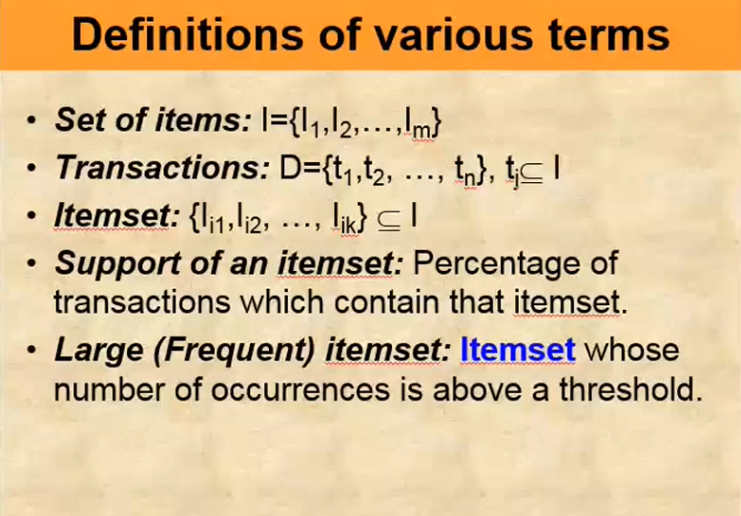

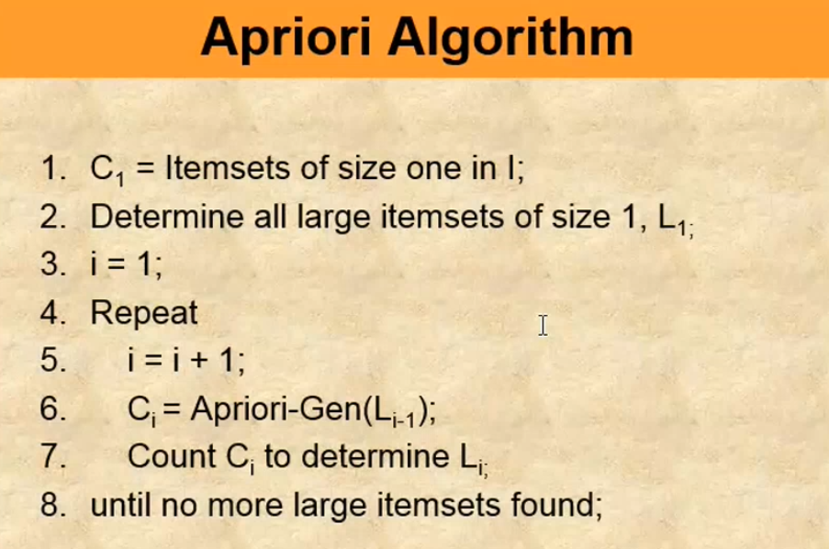

**Result/Observations/Screenshots:**

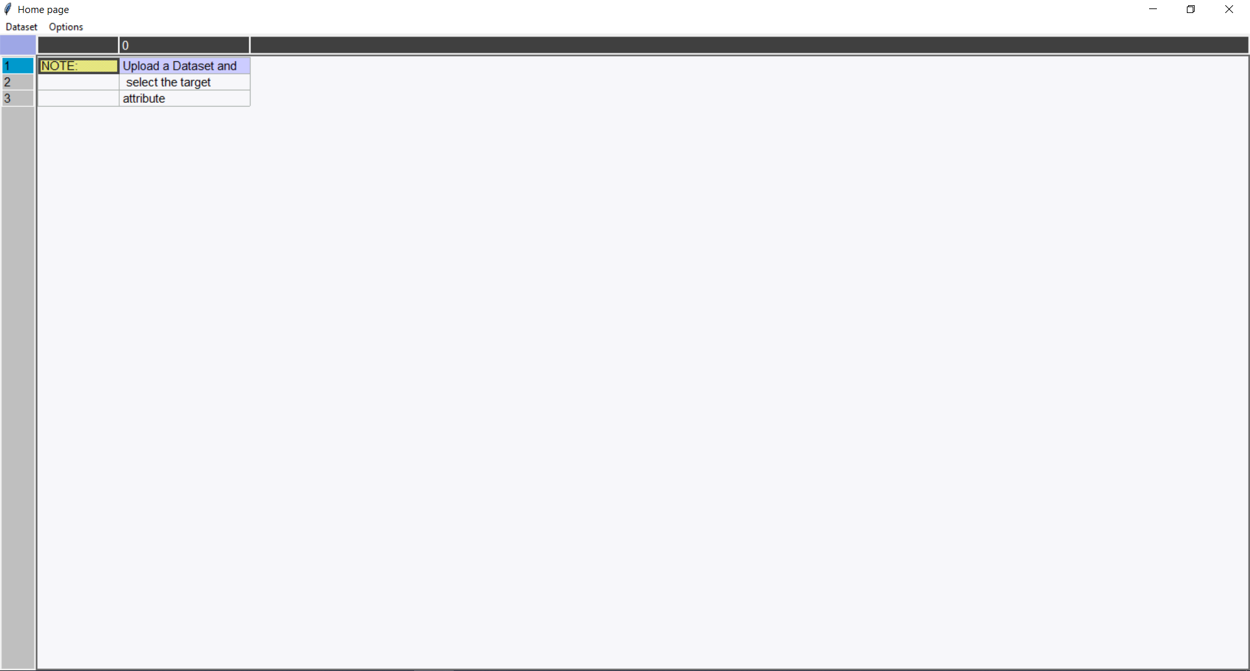

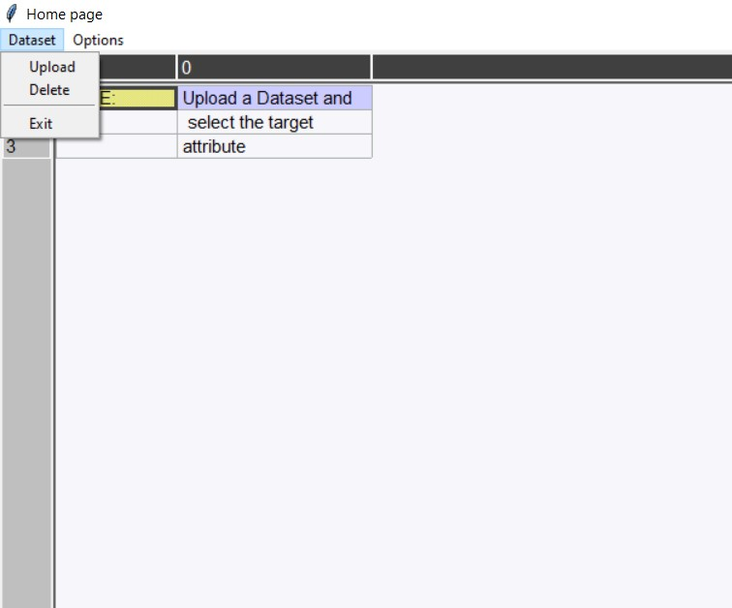



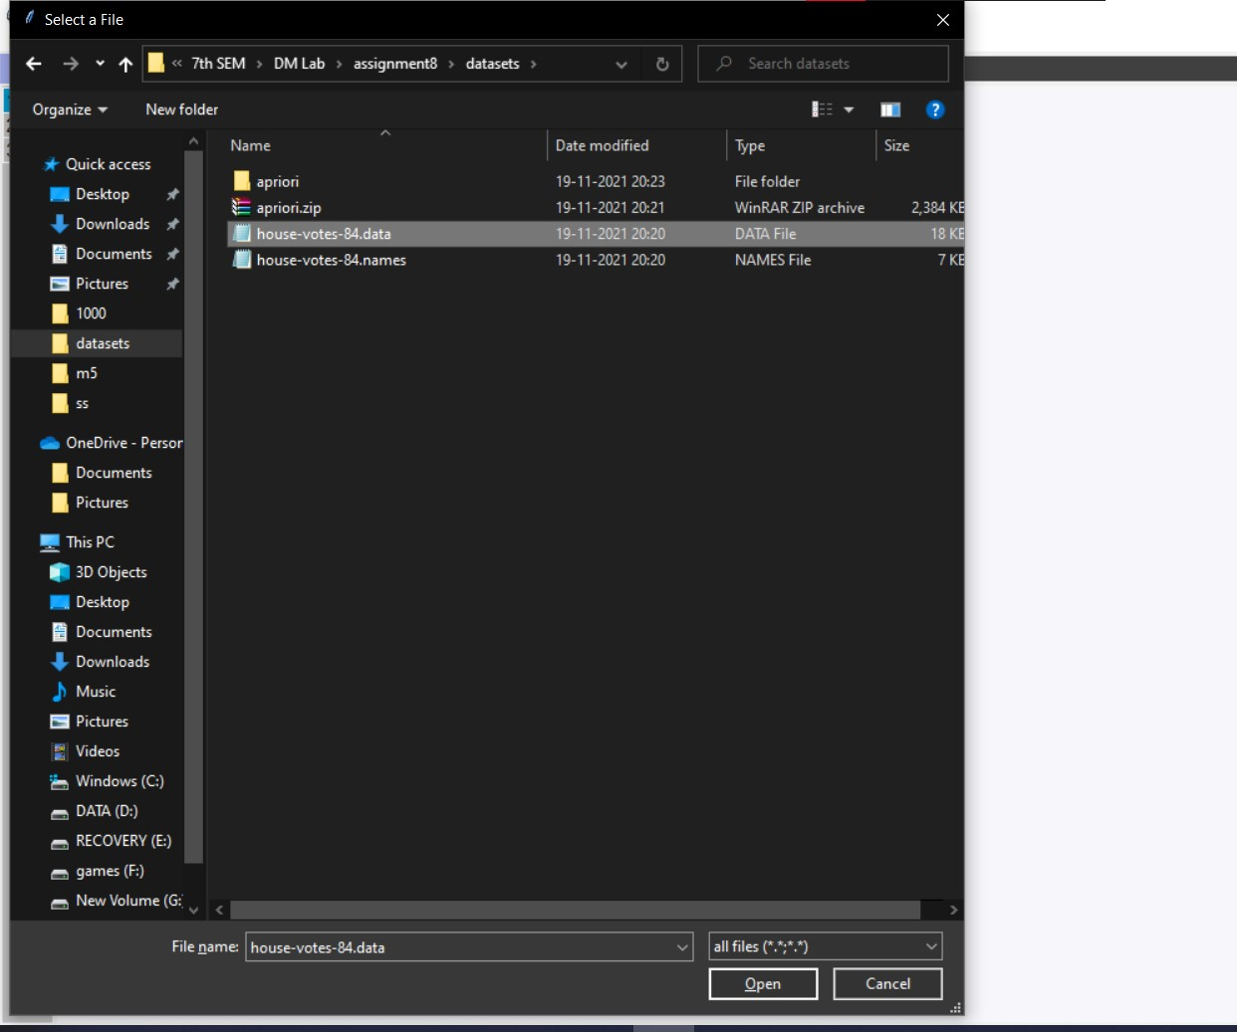

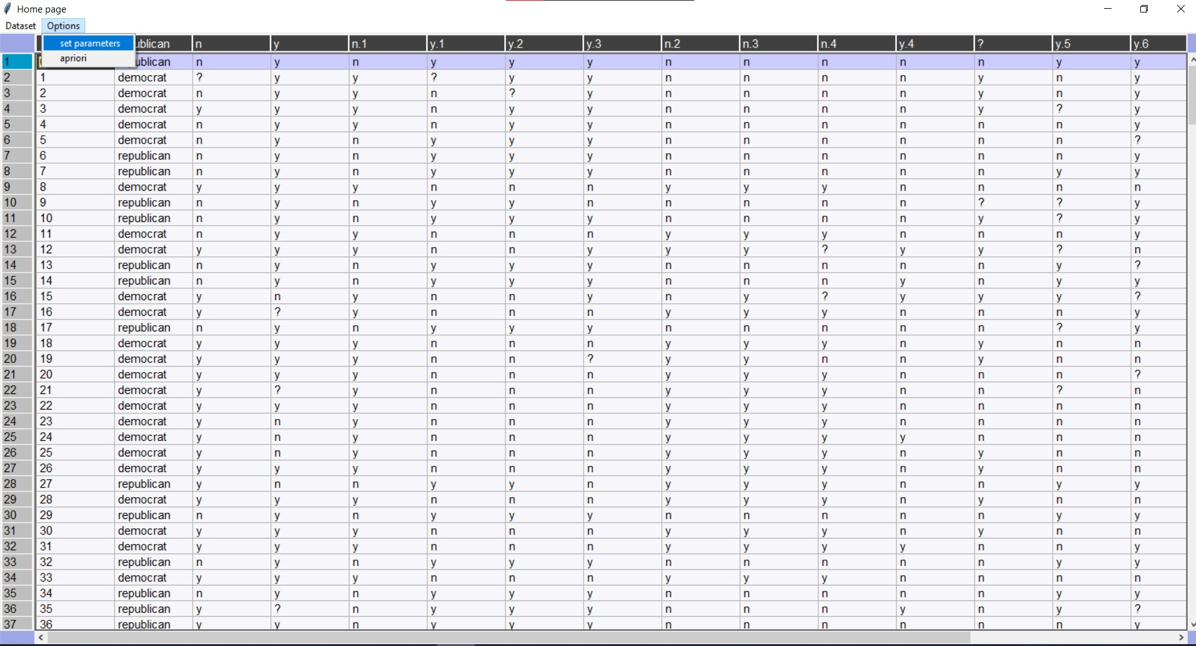

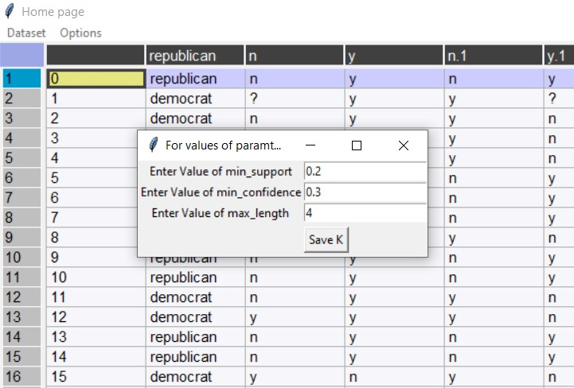

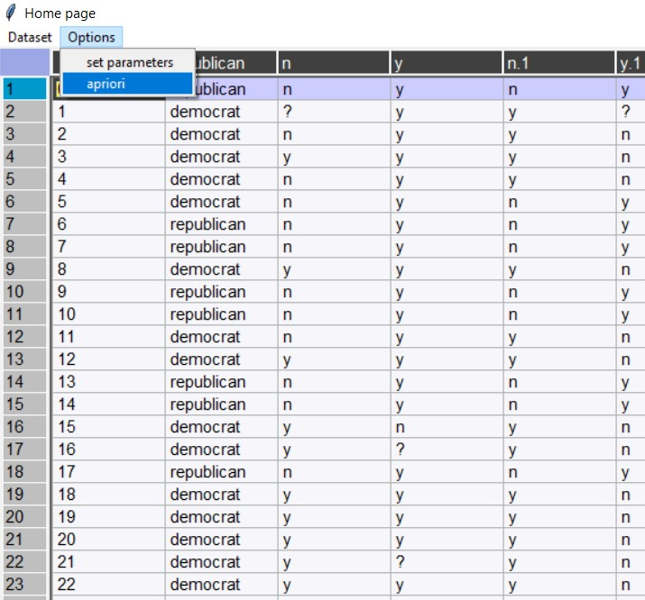

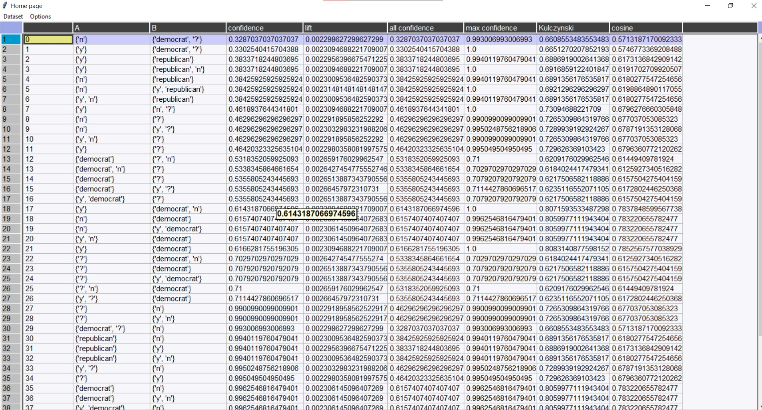

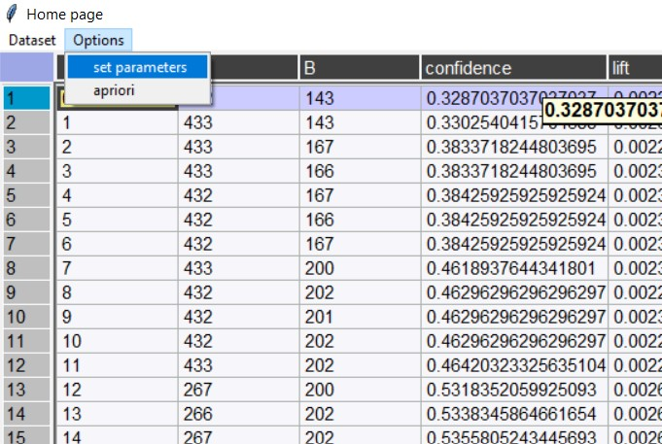

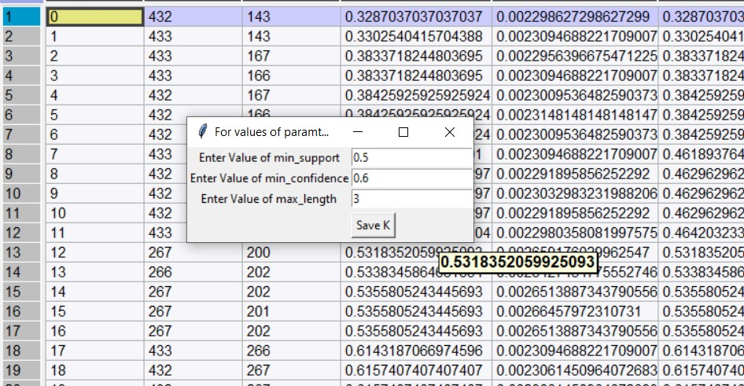

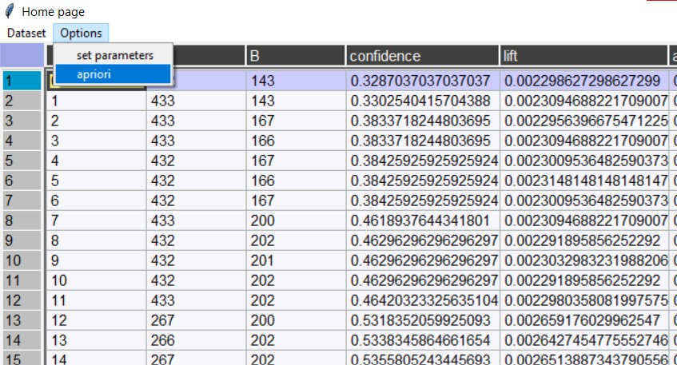

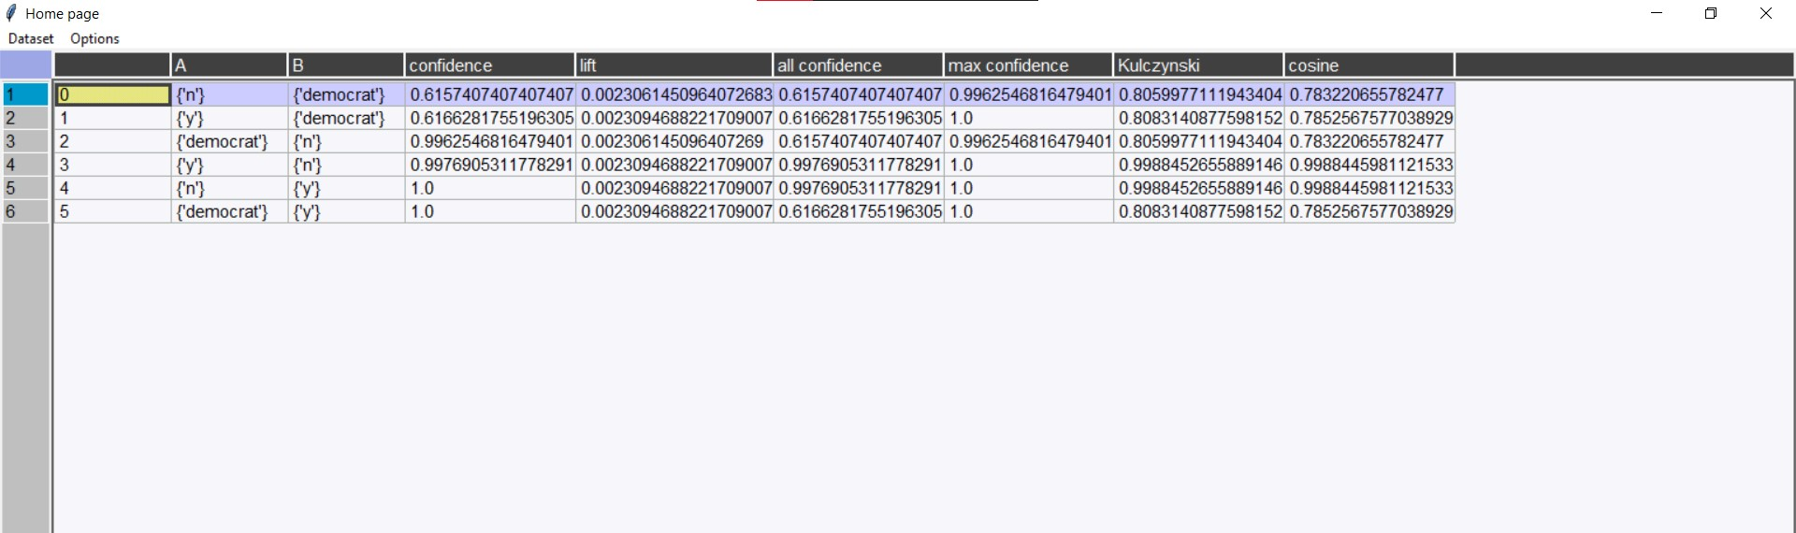

**Conclusion:**

1. Implemented the Apriori algorithm for generating Association Rules

2. Experimented with different values of support, confidence, and maximum rule length.

3. Tabulated the results containing frequent item sets, total number of rules generated

for different support and confidence.

4. Found the interesting rules from above obtained rules using following

metrics/measures

a. Lift

b. Chi-Square Test ᵡ

c. All_confidence measure

d. Max_confidence measure

e. Kulczynski measure

f. Cosine measure